SMA Cross-Over Strategy Results Analysis

1. How the Strategy Works
The Simple Moving Average (SMA) Crossover strategy is a basic trend-following system that uses two moving averages to identify potential changes in market direction. A fast SMA (short-term) reacts quickly to recent prices, while a slow SMA (long-term) smooths out noise and follows the broader trend.
When the fast SMA crosses above the slow SMA, it suggests that momentum is turning bullish and a buy signal is generated. When it crosses below, momentum weakens and the strategy either sells or exits the position.
This approach aims to capture sustained uptrends and avoid large drawdowns during downtrends, though it often enters late and exits late because moving averages are lagging indicators.
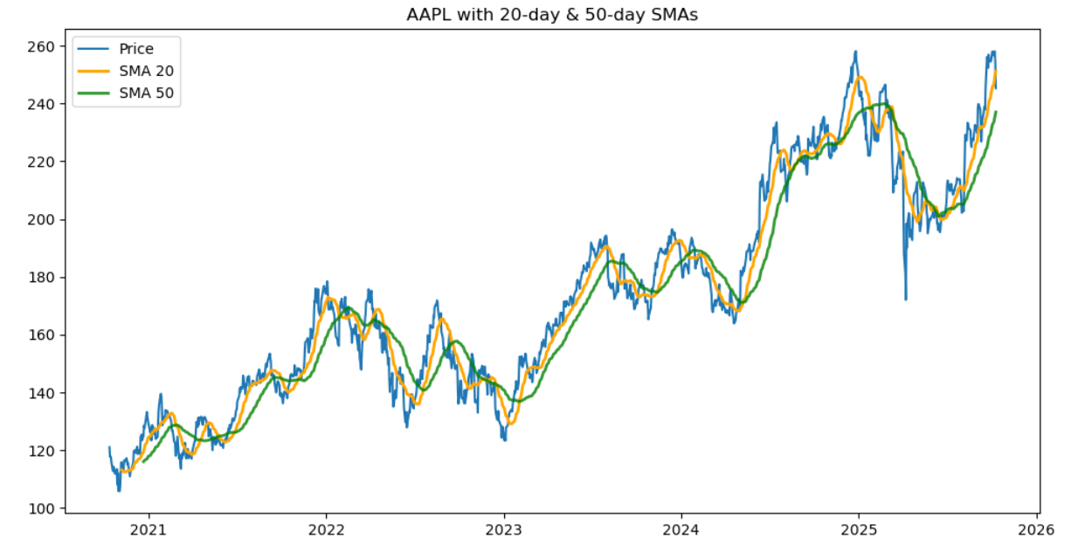
Figure 1: AAPL with 20-day & 50-day SMAs
The chart above shows how the fast (20-day) and slow (50-day) averages track Apple’s price. The fast line hugs price more closely, while the slower one reacts with delay. Their crossovers mark entry and exit points for trades.

2. Detailed Explanation of Results
Both manual and framework implementations produced consistent results that highlight how this strategy behaves in a strong bullish market.
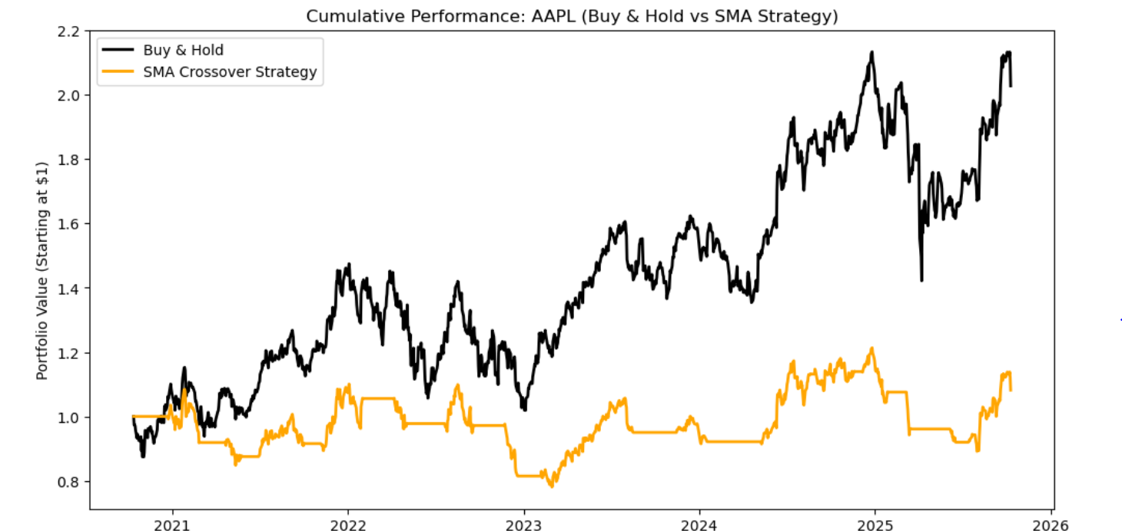
Figure 2: Cumulative Performance: AAPL (Buy & Hold vs SMA Strategy)
In the manual version, the SMA crossover achieved modest gains but significantly underperformed the buy-and-hold benchmark. Apple’s price displayed a long-term upward trend with only temporary corrections. The strategy’s frequent exits during short-term pullbacks caused it to miss large portions of these rallies. Each small reversal produced a crossover, leading to false signals and periods spent out of the market. With trading costs included, total growth reached only around 8%, compared to more than 100% for buy-and-hold.
In the framework implementation (using backtesting.py), results improved.
The system returned roughly +45%, with a Sharpe ratio of 0.38 and a maximum drawdown of about -25%. The difference came from more precise execution, automatic compounding, and the absence of the two-day confirmation filter used in the manual approach.
Still, the overall picture remains the same the SMA crossover lagged behind the market’s full return because it repeatedly exited strong uptrends and re-entered only after confirmation, missing early phases of price recoveries.

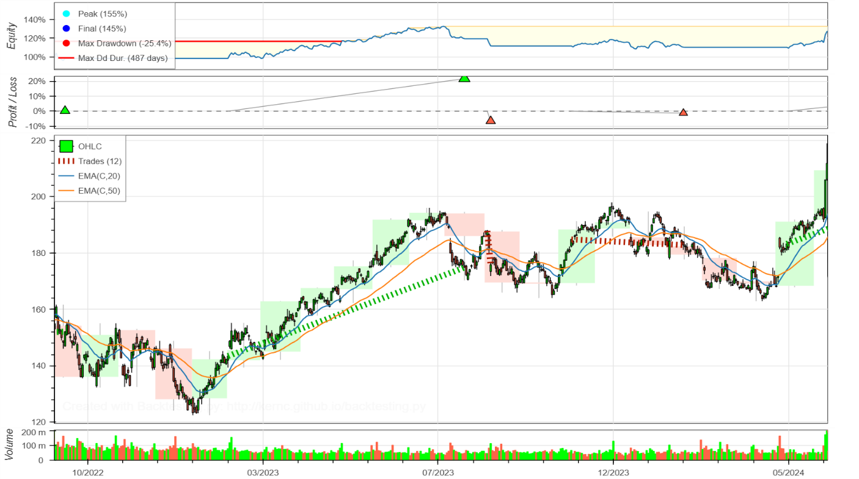
Figure 3: Framework backtest: EMA 20/50 results
The framework plot shows the entry and exit trades (green and red markers) along with equity progression. The system captured some medium-term trends effectively but lost performance during sideways or gently rising periods when crossovers occurred too frequently. The exposure time was around 60%, meaning the strategy stayed out of the market almost 40% of the time, one reason it trails a full-exposure buy-and-hold position.

3. Suitable Market Conditions
The SMA crossover works best in clearly trending or volatile markets where long directional moves are common.
Examples include:
- Commodities like oil, gold, or agricultural futures.
- Foreign exchange markets (Forex), where currencies trend for extended periods.
- Indices or ETFs that experience long bull and bear cycles.
In these environments, the crossover can ride strong momentum and avoid deep losses during reversals.
In contrast, in steady bull markets such as Apple’s long rally, the system underperforms because its lagging signals repeatedly push it out of profitable positions.

4. Ways to Improve the Strategy
Several practical tweaks can improve performance and stability:
- Adjust SMA Windows – Using longer periods such as 50/200 days reduces false crossovers and aligns better with longer trends.
- Use EMA Instead of SMA – Exponential averages respond faster to new data and may capture momentum earlier.
- Add a Threshold (Filter) – Require the fast SMA to exceed the slow SMA by a small percentage (e.g., 0.2%) before entering to avoid micro-crossovers.
- Regime Filtering – Activate the strategy only when the overall market trend (for example, using a 200-day SMA on the index) is upward.
- Optimize Parameters Carefully – Backtest several combinations while guarding against overfitting by using different time periods or assets.
With such improvements, the crossover can become a more effective trend-following tool that balances responsiveness and stability.

5. Summary
Both manual and framework implementations led to consistent conclusions.
The SMA crossover strategy performed positively but underperformed buy-and-hold in a strong trending stock like Apple.
It remains useful in markets characterized by clear directional trends or frequent reversals, where its ability to follow momentum helps reduce drawdowns.
Future refinements such as longer windows, EMA smoothing, or additional filters can improve the balance between risk and return.

